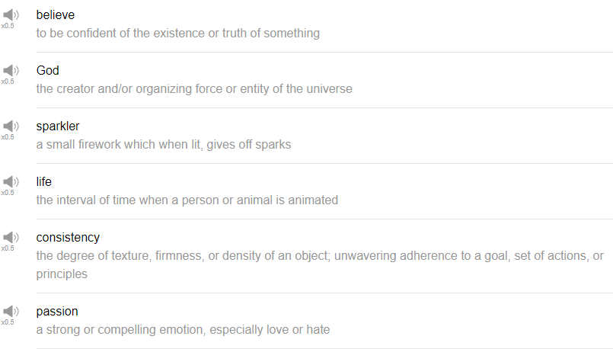

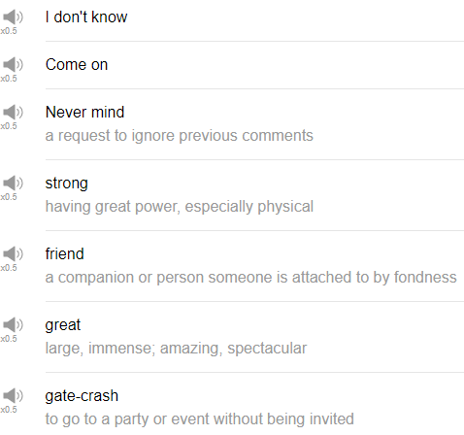

|  |
| --- |
| Hi everybody, my name is Alisha. Today we are going to be talking about the top ten favorite English words. We asked our fans on Facebook what their favorite English words were and these are the top 10 that came out. So let’s talk about them. |
| Come on, the first word or the first phrase is come on. Come on is a phrase that’s used to encourage other people like let’s go to the party, come on or you could also use it with downward intonation as in come on when you feel upset about something. Someone has stopped in front of you on the middle of the street and you are trying to walk but they just don’t move, you can say come on though don’t say that a lot maybe because they might get upset with you. Come on over, come on over baby! That’s a good one. Yeah come on over to my house or come on over to the barbecue this weekend, it’s going to be a good time. So you can use it as part of a separate phrase as well and not just by itself. |
| Believe, the next word is believe. Believe is used, a verb, it’s a verb when you trust in something or that you feel that you know that something exists or something is possible or something is capable. Many people use it as in like I believe in you to show that they think that the other person or the other group of people is capable of doing something or people use it for their faith as well like I believe in god or I don’t believe in God for something that you have your faith in – in another person or in religion or whatever that might be. |
| Consistency, consistency is a noun. The consistency of a liquid can be really thick or kind of thin or you can also use consistency to talk about something that’s important that you need when you are studying a language for example. Consistency, so consistency refers to doing the same thing the same way over and over and over again. Studying every day or making a habit out of studying, creating consistency in your study patterns will really help you in learning another language. We watch our videos every week, we are consistent. |
| Friend, friend, that’s good. I am glad that that was the word that was chosen from the Facebook thing. Friend, yeah so someone that you feel close to or someone that you get along really well with is your friend. In a sentence, I went out drinking with my friends yesterday and that was a bad idea. Friend also can be used for the people who follow you or the people who you are connected to on social media. So your Facebook friends, maybe Twitter, you can have Twitter friends, maybe Instagram friends, people that you haven’t actually met but that you somehow have a connection with online. People are now calling them your friends but whether or not they are true friends remains to be seen. What is the true friend? A true friend is someone who you can tell all your things to and they won’t judge you for it. |
| Gatecrash, this, this. Gatecrash means to go to an event without having been invited to the event. I’ve also heard I am just crashed. I haven’t heard it with gate, but I just heard crash as in to crash a party. So in a sentence, I once crashed a house party. Umm I wasn’t invited but someone – somehow we had a connection and we just showed up and had a good time but usually gatecrashes are perceived as – they are very unwelcome like you shouldn’t be there. |
| Great, great is just a positive word. How are you? I am great. Oh, how was that movie? It was great. Any time that you want to express some sort of positivity, you can use the word great. Great! You are great Ilene. Pizza is pretty great. I haven’t eaten pizza in a while, pizza. |
| I don’t know, I love the phrase, I don’t know. I talked about this phrase in one of the English topics videos that we did with Michael. Check that out if you haven’t already. I don’t know of course is used when you do not know information. You don’t know the answer. Your teacher asks you a question in math class or something and you can say, I don’t know for – I have no idea. So you can use it in this way but I like to use I don’t know a lot to transition in my speech. When I don’t have a good idea or when I am out of things to say and I want to kind of pass the conversation to the next person, I go, I don’t know, I don’t know. You can use this when you are trying to make a decision for example and you kind of want to encourage the other person to like help make the decision. So one person might say, what do you want to do and you can say, I don’t know. What do you want to do? I don’t know what do you want to do and eventually somebody has to make the decision but you can kind of pass back and forth with I don’t know, I don’t know in the sort of soft way. |
| Never mind, yeah never mind means don’t worry about it or maybe like stop thinking about that. I don’t need to think about that anymore. Never mind like you want to move on in the conversation and you can say never mind or you make an embarrassing comment, never mind. What is happening? There is like a cocky thing happening, never mind. Oh I just used it, never mind. No that wasn’t on purpose. So I just used never mind. That was pretty good. |
| Passion, passion refers to something that you feel very strongly about positively usually. So you can feel passion for your studies, you can feel passion for your hobby; you can feel passion for your family or your friend. I think we use passion more so to talk about like a love relationship, a romantic relationship. So you can say I have passion for my wife, I have passion for my husband or like I have passion for this hobby that I do. It’s a really positive word. So in a sentence, let’s see. I think a relationship should be full of passion. I have a passion for music. I do, I have passion for music. I am constantly listening to music. From the moment I wake up in the morning, I literally have headphones in my bed and I am listening to my latest – the latest new things on my SoundCloud stream, that’s true. |
| Sparkler, why did you guys pick sparkler? Sparkler, a sparkler is a small firework like a handheld firework that you can use like on 4th of July, you light one end of it and it kind of goes pss….It makes that sound too, it goes pss…and it kind of burns and you can write stuff and if you take a picture with like a long timer on the camera, that way you can spell out boobs. One of my favorite things to do on the 4th of July in America is to light sparklers with my family and friends. |
| And that’s the end. So those are – let’s see how many? 10, those were ten really cool words that you guys chose from Facebook. Thanks a lot for participating and sending in those words. It’s interesting to see what you guys chose. Thanks again for watching today and we will see you again next time. Bye. We are stirring the pot here at englishclass101.com |